Public Community Member Distribution

Users  - Primary  - Visitors  - Secondary | Phase 1
Intended Outcome
- Visitors interact with community they select as they are served with community profile
Links
- Figma
- https://trello.com/c/FxmkJ2BY/15-draft-build-public-community-members
- …
- …
- …

Introduction
Public Community Members introduces a dedicated section on each community’s public profile, allowing visitors to understand the unique identities, backgrounds, and distribution of its members. For example, in alumni-driven organizations like PPJIU, prospective joiners can see how many members come from each cohort, school, or held specific roles within the organization—such as selection year, school origin, or duty position in Paskibraka. By showcasing these granular traits, Kolavo helps visitors identify kindred backgrounds and feel a direct sense of belonging before joining. This increases both community credibility and motivates new members to connect with organizations where they recognize part of their own journey.

Product Requirement
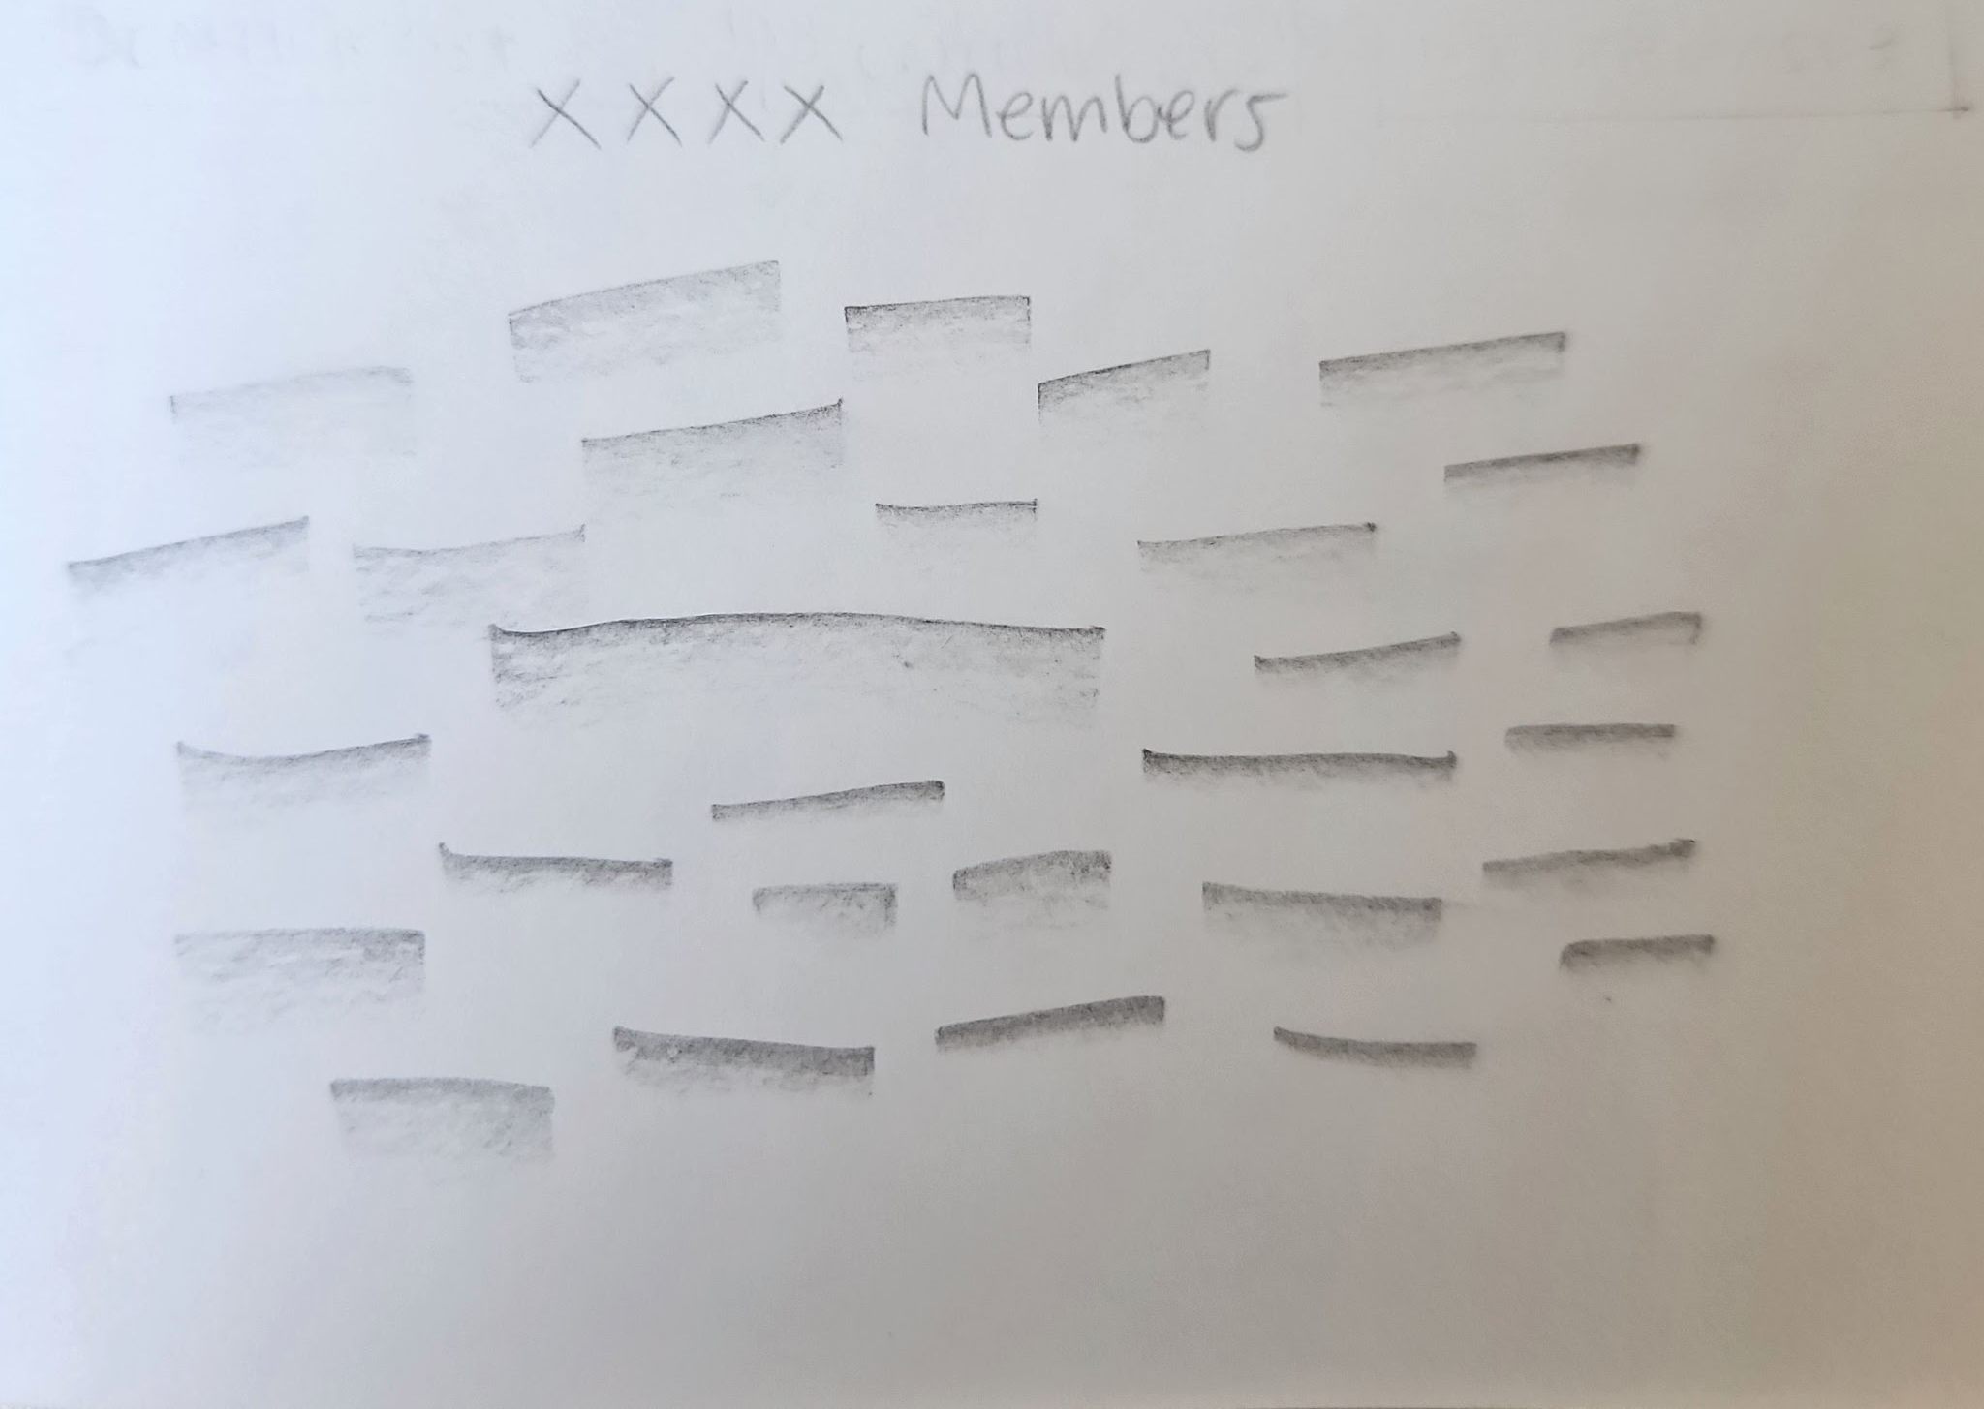
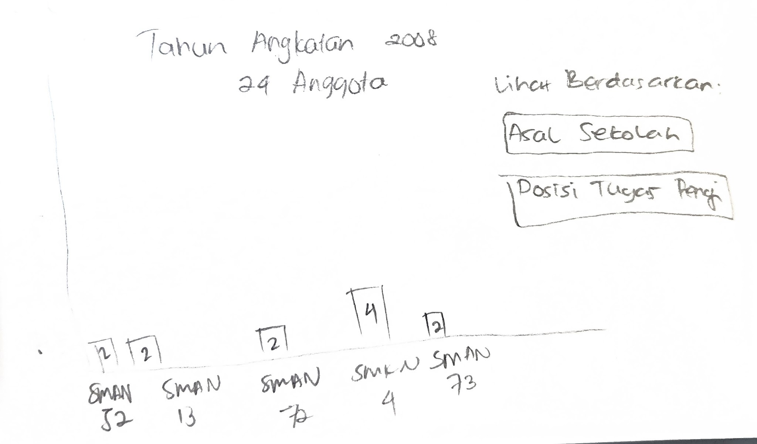
No | User story | Scope | Acceptance Criteria
1 | As a visitor who sees my community profile exists in Kolavo, I want to know how many and what kind of members have joined, in a fun way so I can enjoy while looking at numbers | Attractive and playful community member distribution | - The public community profile page displays a members section with a visually engaging, playful presentation of member distributions.  - Member counts by key identity are clearly shown in a way that makes large numbers feel positive and lively, not overwhelming or dry.  - At least one playful visual element is present in the member section.  - Number of total member can be scanned at a glance without requiring clicks or navigation.  - The presentation works responsively (on both desktop and mobile) and does not become cluttered for very large communities.
2 | As a community manager, I want to see the member information that is uniquely part of my community, so that I can understand and communicate the composition of my organization. | Community’s context aggregated member distribution and breakdowns. | - The members section has a way to display aggregation (counts) for each of the key member identity fields defined in the community.  - The breakdowns are generated based on the actual identity schema of the community (not generic hardcoded fields).  - Each breakdown is labeled clearly and shows the count for each unique value.  - The totals and breakdowns are accurate and consistently updated as members join or leave.
3 | As visitors, I want to the the member information in the community page so I don’t need to click anything once I visit community page | Members section within community page | - The members section is immediately visible on the community page when a visitor lands, without requiring any clicks nor tabs.  - The member section is clearly separated from other sections through spacing or layout cues.  - No login or special permissions are required for visitors to see the aggregated member information.  - The section loads concurrently with the page and does not require an additional manual refresh or interaction.

Design Requirement

Member Header
Design Intent | To make visitor notice how big the community is
Content / Copy | Total member count displays: [Number of Member] Anggota
Visual Requirement | - Use L style which are:  - Font Family: Poppins, sans-serif  - Font Weight: 500  - Font Size: 18px  - Line Height: 24px  - Letter Spacing: -1px  - Text Color: #342621 (Dark Brown)  - Text align: Left  - Capitalization: Title Case
Interaction Behavior | - Number of member changes real time
Acceptance Criteria

Sub Header
Design Intent | To spark visitor’s curiosity to check member distribution
Content / Copy | Intip di Sini 👀 or Cari Tahu di Sini 👇🏻
Visual Requirement | - Use caption style which are:  - Font Family: Poppins, sans-serif  - Font Weight: Regular  - Font Size: 14px  - Line Height: 24px  - Letter Spacing: -1px  - Text Color: #342621 (Dark Brown)  - Text align: centre  - Capitalization: Title Case
Interaction Behavior | - None
Acceptance Criteria

Member Distribution Tag Cloud (Interactive)
Design Intent | Let visitors grasp the diversity and depth of a community at a glance, invite playful exploration, and allow for deeper analysis with one click. The experience is lively, simple, and celebrates the uniqueness of member backgrounds using an organic tag/word cloud, rather than dry bar charts.
Content / Copy | - Each keyword represents a major member group or any other identity/dimension field configured by the community.
Visual Requirement | - Rectangle space:  - Tag/word cloud occupies prominent, central rectangle space in the section  - Maximum height: 430px (mobile), 260px (desktop)  - Keyword text:  - Font Family: Poppins, sans-serif  - Font Weight: Regular  - Font Size: 14px  - Line Height: 24px  - Letter Spacing: -1px  - Text Color: #FFFEFD  - Text align: centre  - Capitalization: Title Case  - Tag cloud:  - Weight: respective to keywords with 10px margin at the left and right side of the words  - Height: relative to the keyword member size, the greater the size, the thicker the height. Minimum 24px, maximum 84px.  - Color code shows different category of tag, first category is 100% transparent, decrease the percentage for the following category  - Tags are center aligned within the rectangle space  - Reposition/reflow as the data or browser width changes  - Rotating in order repeat: 5, -5, 0, -5, 5, -5, 5, 0, 5, -5 degrees.  - Maximum show 20 tags
Interaction Behavior | - Each keyword/tag is clickable (hover cursor when desktop, tap when mobile)  - On hover/tap, tag cloud slightly pops  - On click/tap: surface a horizontal bar chart or modal showing an exact breakdown for that field  - If tag cloud is too small (group count very low), still allow click—may just show bar with one/few members  - On click, the tag cloud stays visible but the bar chart view overlays within a modal  - Clicking another word switches the bar chart to a different category view
Acceptance Criteria

Modal Members Distribution Bar Chart
Design Intent | Enable visitors and members to discover the inner diversity of a community’s member group, getting rich breakdowns in a single, playful, intuitive chart.
Content / Copy | - Modal title: [Category Name] [Chosen Tag]  - Modal subtitle: [Number of member of chosen tag] Anggota  - Chips options title: Lihat berdasarkan:  - Chips label: [Sub category name]  - Sorting from the greatest function: Terbanyak  - Sorting from the least function: Tersedikit  - Bar title: [subgroup label]  - Bar number: [number per subgroup]
Visual Requirement | - Modal  - Modal: round rectangle shape  - Modal Fill #FFFEFD  - Modal border: 1px, transparent, using the current community theme color.  - Shadow: soft for elevation, not overpowering  - Modal Title, use L style which are:  - Font Family: Poppins, sans-serif  - Font Weight: 500  - Font Size: 18px  - Line Height: 24px  - Letter Spacing: -1px  - Text Color: #342621 (Dark Brown)  - Text align: Left  - Capitalization: Title Case  - Modal Subtitle  - Font Family: Poppins, sans-serif  - Font Weight: 500  - Font Size: 16px  - Line Height: 24px  - Letter Spacing: -1px  - Text Color: #6B7280 (Grey)  - Text align: Left  - Capitalization: Title Case  - Chips options title  - Font Family: Poppins, sans-serif  - Font Weight: 500  - Font Size: 14px  - Line Height: 24px  - Letter Spacing: -1px  - Text Color: #342621 (Grey)  - Text align: Left  - Capitalization: Title Case  - Chips Active  - Font Family: Poppins, sans-serif  - Font Weight: 500  - Font Size: 13px  - Line Height: 19.5px  - Letter Spacing: -1px  - Text Color: #FFFFFD  - Text align: Left  - Capitalization: Title Case  - Fill: main color theme chosen  - Chips Inactive  - Font Family: Poppins, sans-serif  - Font Weight: 500  - Font Size: 13px  - Line Height: 19.5px  - Letter Spacing: -1px  - Text Color: #6B7280  - Text align: Left  - Capitalization: Title Case  - Fill: #F3F4F6  - Sorting Label  - Font Family: Poppins, sans-serif  - Font Weight: 500  - Font Size: 13px  - Line Height: 19.5px  - Letter Spacing: -1px  - Text Color: #6B7280  - Text align: Left  - Capitalization: Title Case  - Bar Title  - Font Family: Poppins, sans-serif  - Font Weight: 500  - Font Size: 14px  - Line Height: 21px  - Letter Spacing: -1px  - Text Color: #342621  - Text align: Left  - Capitalization: Title Case  - Bar Number  - Font Family: Poppins, sans-serif  - Font Weight: 500  - Font Size: 14px  - Line Height: 21px  - Letter Spacing: -1px  - Text Color: main community theme color  - Text align: right  - Bar  - Max 10 bars: 9 individual bars + “Lainnya” (Others) for remaining.  - First uses the main community theme color.  - Each subsequent bar gets lower brightness (tint/desaturate; e.g., use theme color with 85%, 70%, ... of brightness).  - Bar background: no gradient, flat fill.  - All chart/legend elements are horizontally centered.  - Height of bars and labels is responsive to device size.
Interaction Behavior | - Modal opens when a tag is clicked in the tag cloud.  - Clicking sort function dynamically change the bar data and visual  - Clicking outside closes the modal (or a clear close icon is provided).  - Modal and chart responsive for mobile and desktop.
Acceptance Criteria

Engineering Requirement

Questions

